✴

# Document an existing experience

Narrow your focus to a specific scenario or process within an existing product or service. In the **Steps** row, document the step-by-step process someone typically experiences, then add detail to each of the other rows.

### TIP

As you add steps to the experience, move each these “Five Es” the left or right depending on the scenario you are documenting.

# Entice

**SCENARIO**

**Browsing, booking, attending, and rating a local city tour**

How does someone initially become aware of this process?

# Enter

What do people experience as they begin the process?

# Engage

In the core moments in the process, what happens?

**emplate T**

**Customer experience journey map**

Use this framework to better understand customer needs, motivations, and obstacles by illustrating a key scenario or process from start to finish.

When possible, use this map to document and summarize interviews and observations with real people rather than relying on your hunches or assumptions.

Created in partnership with

[**Share template feedback**](https://muralco.typeform.com/to/CiqaHVat?typeform-source=app.mural.co)

**Need some inspiration?**

See a finished version

# Exit

What do people typically experience

as the process finishes?

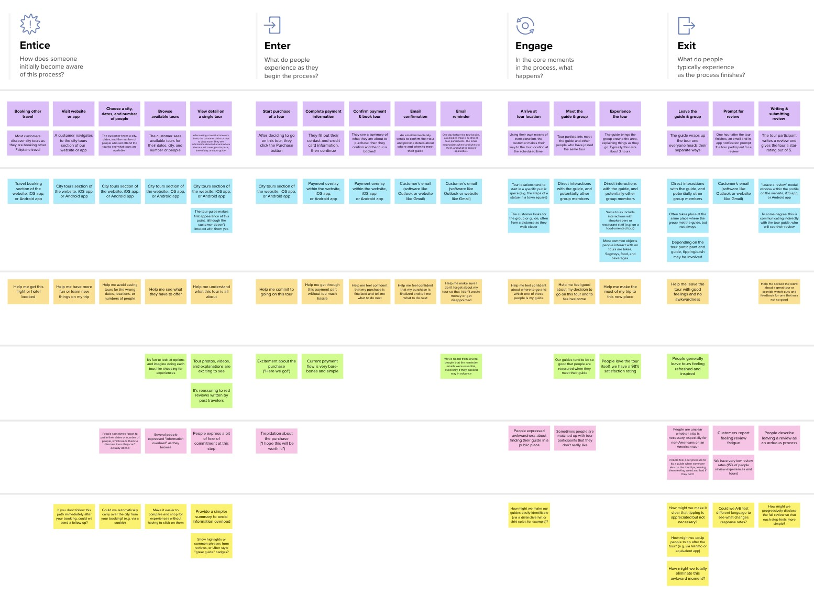

**Steps**

Facebook

Google

Login through the Google

Login through the Facebook

Login through the Gmail

Gmail

By data analytics, user gain a knowledge of their health reports.

User can enter their medical record and symptoms to keep update of their health condition

Feedback

Suggestion and reviews

Rating

What does the person (or group) typically experience?

Create account by entering mail and password, after verified by OTP, user will be logged in

App searches user's facebook id. if it exist user will be logged in

App searches user's google account. if it exist user will be logged in

Create account by entering mail and password,after verified by OTP, user will be logged in

App searches user's facebook id. if it exist, user will be logged in

App searches user's google account. if it exist, user will be logged in

## Interactions

data visualization & insights

About account

collect user's basic details like name, age, gender, height, weight, etc

Suggestion box will pop out when exit

Good rating via API

Symptom entry

collect medical records

Home page

User can view their previous predictions and medical reports that have been compiled together for the easy usage of prediction

What interactions do they have at each step along the way?

Contain prediction results in a visualization form.

Contain user information, medical background & other settings

Doctor suggestion and consultation

Prediction and visualization

Contain modules to collect medical records,entry symptoms.

**People:** Who do they see or talk to?

**Places:** Where are they?

**Things:** What digital touchpoints or physical objects would they use?

## Goals & motivations

To get remidies and prescription to avoid disease

To get suggestion from expert doctor simply in home immediately

To get track of their heart condition day and night

Help me to get clear knowledge of user health condition

Help me to predict heart disease

According to the health condition, slogan will be generated for the user which inspire user to keep maintain their condition

At each step, what is a person’s primary goal or motivation? (“Help me...” or “Help me avoid...”)

## Positive moments

Clear information communication

User feel motivated when app provides adequate information

Improved prediction system

Detailed explanation about the diseases

Positive result from the prediction

Easy to access and visualize the prediction

Detailed information about diseases

What steps does a typical person find enjoyable, productive, fun, motivating, delightful, or exciting?

## Negative moments

User friendly environment

If app doesn't provide reliable information , user feel discontent

Cost-effective method

Knowing health condition from home

Trust

Bewilderment

Fear about their health condition

What steps does a typical person find frustrating, confusing, angering, costly, or time-consuming?

## Areas of opportunity

Learn about treatment and self- care

Social sharing

Incorporate new desired activities

Staying informed about the diseases

Healthy lifestyle recommendation

Displaying symptoms related to heart diseases

Suggestion to avoid heart diseases

How might we make each step better? What ideas do we have? What have others suggested?

of this template to kickstart your work.

[**Open example**](https://app.mural.co/template/f59f644b-b4b4-47b5-9ed6-3a8c71ceb612/896b31fe-5597-40ef-9b06-3811a1a45ace)